DEVELOPMENT AND CLINICAL VALIDATION OF PEPRISC-VOICE: A SPEECH-ENABLED AI SYSTEM FOR REAL-TIME PEP RISK PREDICTION
Richu Ravikumar¹, Emily Guan¹, Saju Denishya Prabhakaran¹, Srived Meda¹, Dhanush Gajula¹, Susanth Durgaraju¹, Eshwar Kolluru¹, Romik Srivastava¹, Jianing Li¹, Todd Brenner¹, Swaroop Vedula¹, Daniel Kashabi¹, Venkata Akshintala¹
- Division of Gastroenterology, Johns Hopkins Hospital, Baltimore, MD
Background: Accurate point-of-care prediction of post-ERCP pancreatitis (PEP) remains a major gap, with prophylaxis still driven by subjective gestalt. Existing prediction tools require manual calculations and lack intraprocedural adaptability. We developed PEPRisc, a validated machine-learning PEP risk calculator trained on 12 randomized trials (n=7,389, AUC=0.74) and EndoScribe, an ambient AI documentation system that can transcribe procedural dictation. We integrated these technologies to create a fully hands-free, clinician-facing, speech-enabled video interface that continuously updates and displays real-time PEP risk estimates during ERCP. (Fig 1) We aimed to validate automated PEPRisc variable capture and risk estimation using EndoScribe against chart-abstracted ground truth.
Methods: Performance was evaluated using retrospective ERCP data and simulated procedural dictations by trained endoscopists to mirror in-suite reporting. Structured chart review established ground-truth PEPRisc inputs and PEP outcomes. EndoScribe processed these recordings to extract variables and generate baseline and prophylaxis specific PEP risk estimates. Variable extraction accuracy and risk prediction agreement between models were quantified. Discrimination was assessed using DeLong's test. In a two-month prospective pilot, real-time in-suite ERCP audio recordings underwent parallel chart abstraction and were included into the testing. 6 endoscopists assessed the speech-enabled interface through structured usability testing.
Results: The model was evaluated on 237 ERCP procedures and successfully generated PEP risk estimates (<5s) in 100% of cases without needing manual correction. Variable extraction achieved high overall agreement with across all risk factors (Fig 2A). Baseline PEP risk estimates showed mean absolute error of 4.78% (95% CI: 3.84-5.73%) compared to ground-truth calculations, with good reliability (ICC=0.67). Bland-Altman analysis revealed minimal systematic bias of 3.18% with 95% limits of agreement [-12.72, 19.08]. (Fig 2B) Performance was similar across all prophylaxis scenarios (Fig 2A). Discrimination for risk estimation was preserved between manual and EndoScribe-derived risk predictions (DeLong p=0.948), indicating automated extraction did not degrade performance. Mean satisfaction score was 4.7/5, with 5/6 endoscopists reporting good workflow fit.
Conclusion: PEPRisc-Voice delivers continuous, hands-free risk prediction directly from procedural speech, eliminating workflow interruption and manual data entry. By providing real-time, dynamically updated risk estimates, it can guide optimal prophylaxis strategy selection and post-procedure disposition, potentially standardizing prevention practices and reducing post-ERCP morbidity. This work also demonstrates feasibility for real-time AI decision support integrated into routine endoscopy.
Fig 02. (A) Performance of EndoScribe-integrated PEPRisc for variable extraction and risk prediction (B) Agreement between EndoScribe-derived and ground-truth baseline PEP risk estimates. Bland–Altman plot comparing automated EndoScribe-derived and chart-abstracted (manual) baseline PEPRisc estimates of post-ERCP pancreatitis risk.
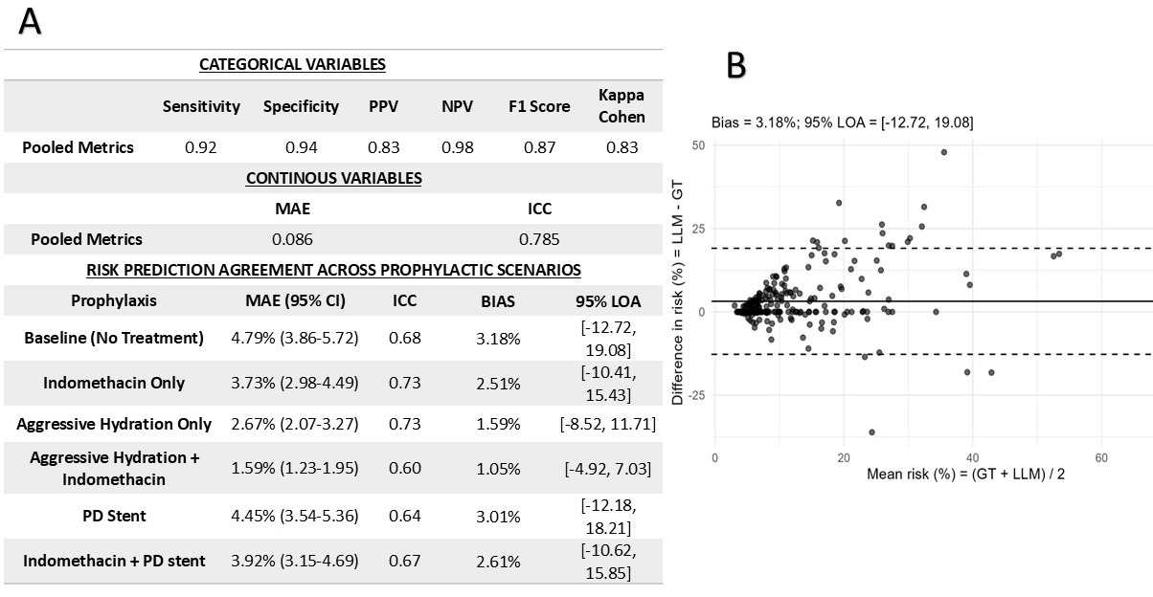
Fig. 1 Real-time speech-to-PEPRisc workflow showing dictation, transcription, PEPRisc calculation and immediate risk display during ERCP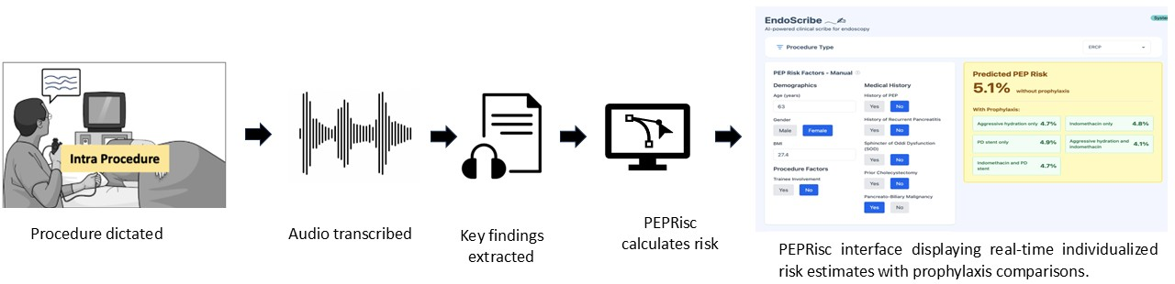

Abbreviations: PPV, positive predictive value; NPV, negative predictive value; MAE, mean absolute error; ICC, intraclass correlation coefficient; LOA, limits of agreement; PD, pancreatic duct.

